HANDWRITTEN DIGITS RECOGNITION
Dissertation submitted in fulfilment of the requirements for the Degree of

BACHELOR OF TECHNOLOGY
in
COMPUTER SCIENCE AND ENGINEERING

By
SANJAY NEELARAPU
Registration number: 12109553

Supervisor
MR. VED PRAKASH CHAUBEY


School of Computer Science and Engineering
Lovely Professional University
Phagwara, Punjab (India)
April 2024

@ Copyright LOVELY PROFESSIONAL UNIVERSITY, Punjab (INDIA)
Month April, Year 2024
ALL RIGHTS RESERVED
DECLARATION STATEMENT

I hereby declare that the research work reported in the dissertation/dissertation proposal entitled "HANDWRITTEN DIGITS RECOGNITION” in partial fulfilment of the requirement for the award of Degree for Bachelor of Technology in Computer Science and Engineering at Lovely Professional University, Phagwara, Punjab is an authentic work carried out under supervision of my research supervisor Mr. Ved Prakash Chaubey. I have not submitted this work elsewhere for any degree or diploma. I understand that the work presented herewith is in direct compliance with Lovely Professional University’s Policy on plagiarism, intellectual property rights, and highest standards of moral and ethical conduct. Therefore, to the best of my knowledge, the content of this dissertation represents authentic and honest research effort conducted, in its entirety, by me. I am fully responsible for the contents of my dissertation work.

Signature of Candidate
Sanjay Neelarapu

SUPERVISOR’S CERTIFICATE

This is to certify that the work reported in the B. Tech Dissertation/dissertation proposal entitled “HANDWRITTEN DIGITS RECOGNITION”, submitted by Sanjay Neelarapu at Lovely Professional University, Phagwara, India is a bonafide record of his original work carried out under my supervision. This work has not been submitted elsewhere for any other degree.

Signature of Supervisor

Ved Prakash Chaubey
Date:
Counter Signed by:
- Concerned HOD:
HoD’s Signature: ________________
HoD Name: ____________________
Date: ___________________

- Neutral Examiners:
External Examiner
Signature: _______________
Name: __________________
Affiliation: ______________
Date: ___________________
Internal Examiner
Signature: _______________
Name: __________________
Date: ___________________
TABLE OF CONTENTS

CONTENTS PAGE NO.

Inner first page – Same as cover i
PAC form ii
Abstract iii
Declaration by the Scholar iv
Supervisor’s Certificate v
Table of Contents vi

CHAPTER1: INTRODUCTION
CHAPTER2: RELATED WORK
CHAPTER3: METHODOLOGY
  - DATASET
  - LINEAR REGRESSION
  - LOGISTIC REGRESSION
  - SVM
  - RANDOM FOREST CLASSIFIER
  - KNN
  - CNN

TABLE OF CONTENTS

CONTENTS PAGE NO.

CHAPTER4: IMPLEMENTATION
CHAPTER5: RESULTS AND DISCUSSIONS
CHAPTER6: CONCLUSION AND FUTURE SCOPE
5.1 CONCLUSION
5.2 FUTURE SCOPE

ABSTRACT
The reliance of humans over machines has never been so high such that from object classification in photographs to adding sound to silent movies everything can be performed with the help of deep learning and machine learning algorithms. Likewise, Handwritten text recognition is one of the significant areas of research and development with a streaming number of possibilities that could be attained. Handwriting recognition (HWR), also known as Handwritten Text Recognition (HTR), is the ability of a computer to receive and interpret intelligible handwritten input from sources such as paper documents, photographs, touch-screens and other devices [1]. Apparently, in this paper, we have performed handwritten digit recognition with the help of MNIST datasets using Support Vector Machines (SVM), Multi-Layer Perceptron (MLP) and Convolution Neural Network (CNN) models. Our main objective is to compare the accuracy of the models stated above along with their execution time to get the best possible model for digit recognition.

INTRODUCTION
Handwritten digit recognition is the ability of a computer to recognize the human handwritten digits from different sources like images, papers, touch screens, etc, and classify them into 10 predefined classes (0-9). This has been a topic of boundless-research in the field of deep learning. Digit recognition has many applications like number plate recognition, postal mail sorting, bank check processing, etc [2]. In Handwritten digit recognition, we face many challenges because of different styles of writing of different peoples as it is not an Optical character recognition. This research provides a comprehensive comparison between different machine learning and deep learning algorithms for the purpose of handwritten digit recognition. For this, we have used Support Vector Machine, Multilayer Perceptron, and Convolutional Neural Network. The comparison between these algorithms is carried out on the basis of their accuracy, errors, and testing-training time corroborated by plots and charts that have been constructed using matplotlib for visualization. The accuracy of any model is paramount as more accurate models make better decisions. The models with low accuracy are not suitable for real-world applications. Ex- For an automated bank cheque processing system where the system recognizes the amount and date on the check, high accuracy is very critical. If the system incorrectly recognizes a digit, it can lead to major damage which is not desirable. That’s why an algorithm with high accuracy is required in these real-world applications. Hence, we are providing a comparison of different algorithms based on their accuracy so that the most accurate algorithm with the least chances of errors can be employed in various applications of handwritten digit recognition. This paper provides a reasonable understanding of machine learning and deep learning algorithms like SVM, CNN, and MLP for handwritten digit recognition. It furthermore gives you the information about which algorithm is efficient in performing the task of digit recognition. In further sections of this paper, we will be discussing the related work that has been done in this field followed by the methodology and implementation of all the three algorithms for the fairer understanding of them. Next, it presents the conclusion and result bolstered by the work we have done in this paper. Moreover, it will also give you some potential future enhancements that can be done in this field. The last section of this paper contains citations and references used.

RELATED WORK
With the humanization of machines, there has been a substantial amount of research and development work that has given a surge to deep learning and machine learning along with artificial intelligence. With time, machines are getting more and more sophisticated, from calculating the basic sums to doing retina recognition they have made our lives more secure and manageable. Likewise, handwritten text recognition is an important application of deep learning and machine learning which is helpful in detecting forgeries and a wide range of research has already been done that encompasses a comprehensive study and implementation of various popular algorithms like works done by S M Shamim [3], Anuj Dutt [4], Norhidayu binti [5] and Hongkai Wang [8] to compare the different models of CNN with the fundamental machine learning algorithms on different grounds like performance rate, execution time, complexity and so on to assess each algorithm explicitly. [3] concluded that the Multilayer Perceptron classifier gave the most accurate results with minimum error rate followed by Support Vector Machine, Random Forest Algorithm, Bayes Net, Na¨ıve Bayes, j48, and Random Tree respectively while [4] presented a comparison between SVM, CNN, KNN, RFC and were able to achieve the highest accuracy of 98.72% using CNN (which took maximum execution time) and lowest accuracy using RFC. [5] did the detailed study-comparison on SVM, KNN and MLP models to classify the handwritten text and concluded that KNN and SVM predict all the classes of dataset correctly with 99.26% accuracy but the thing process goes little complicated with MLP when it was having trouble classifying number 9, for which the authors suggested to use CNN with Keras to improve the classification. While [8] has focused on comparing deep learning methods with machine learning methods and comparing their characteristics to know which is better for classifying mediastinal lymph node metastasis of non-small cell lung cancer from 18 F-FDG PET/CT images and also to compare the discriminative power of the recently popular PET/CT texture features with the widely used diagnostic features. It concluded that the performance of CNN is not significantly different from the best classical methods and human doctors for classifying mediastinal lymph node metastasis of NSCLC from PET/CT images. However, CNN does not make use of the import diagnostic features, which have been proved more discriminative than the texture features for classifying smallsized lymph nodes. Therefore, incorporating the diagnostic features into CNN is a promising direction for future research. All we need is lots of data and information and we will be able to train a big neural net to do what we want, so a convolution can be understood as “looking at functions surrounding to make a precise prognosis of its outcome.” [6], [7] has used a convolution neural network for handwritten digit recognition using MNIST datasets. [6] has used 7 layered CNN model with 5 hidden layers along with gradient descent and back prorogation model to find and compare the accuracy on different epochs, thereby getting maximum accuracy of 99.2% while in [7], they have briefly discussed different components of CNN, its advancement from LeNet-5 to SENet and comparisons between different model like AlexNet, DenseNet and ResNet. The research outputs the LeNet-5 and LeNet-5 (with distortion) achieved test error rate of 0.95% and 0.8% respectively on MNIST data set, the architecture and accuracy rate of AlexNet is same as LeNet-5 but much bigger with around 4096000 parameters and “Squeeze-and-Excitation network” (SENet) have become the winner of ILSVRC-2017 since they have reduced the top-5 error rate to 2.25% and by far the most sophisticated model of CNN in existence.

METHODOLOGY
The comparison of the algorithms (Support vector machines, Multi-layered perceptron and Convolutional neural network) is based on the characteristic chart of each algorithm on common grounds like dataset, the number of epochs, complexity of the algorithm, accuracy of each algorithm, specification of the device (Windows 11 i3 processor) used to execute the program and runtime of the algorithm, under ideal condition.
A. DATASET
Handwritten character recognition is an expansive research area that already contains detailed ways of implementation which include major learning datasets, popular algorithms, features scaling and feature extraction methods. MNIST dataset (Modified National Institute of Standards and Technology database) is the subset of the NIST dataset which is a combination of two of NIST’s databases: Special Database 1 and Special Database 3. Special Database 1 and Special Database 3 consist of digits written by high school students and employees of the United States Census Bureau, respectively. MNIST contains a total of 70,000 handwritten digit images (60,000 - training set and 10,000 - test set) in 28x28 pixel bounding box and anti-aliased. All these images have corresponding Y values which apprises what the digit is.

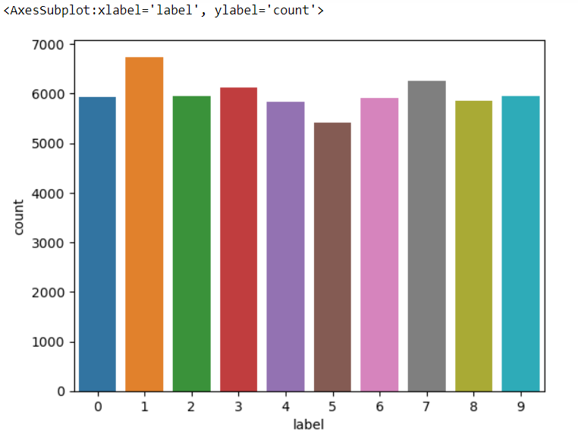
Figure 1. Bar graph illustrating the MNIST handwritten digit training dataset (Label vs Total number of training samples).

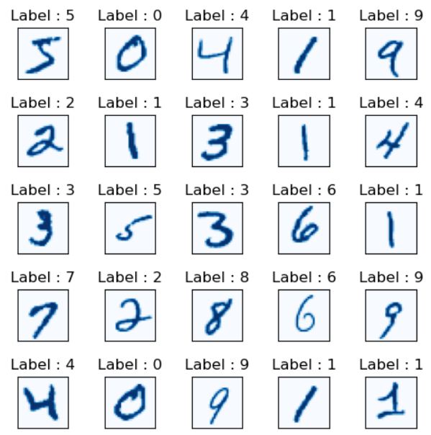
Figure 2. Plotting of some random MNIST Handwritten digits.

B. LINEAR REGRESSION
We used the MNIST dataset, which contains 10,000 test images and 60,000 training images of handwritten digits spanning from 0 to 9, for our work on handwritten digit recognition using linear regression. Assuming a linear relationship between input data and output labels, linear regression may not be the best option given the complexity of handwritten digit identification. In order to address the multi-class classification issue that arises naturally during digit recognition, we implemented the One-vs-All (OvA) technique. Ten different linear regression models were trained in this manner, each with the responsibility of differentiating one digit class from the others. The feature vectors were used as input for each linear regression model, and the accompanying binary labels (0 or 1) were used as output. Each digit's specific model was trained to predict whether or not an input image represented that digit.
One-vs-All Technique
If there are K different classes in a data-set, we will first build a model where we consider the data belonging to one class as positive, and all other classes as negative. Next, we will build another model assuming the data belonging to some other class as positive and the remaining as negative. We shall keep repeating the process until we build K different models. Let us understand this better with the help of an example. In the below figure, we have data belonging to 3 different classes. Hence, we will build 3 different models considering one particular class of data as positive and the remaining as negative. In general, if there are K classes in the data-set, we need to build K different models.

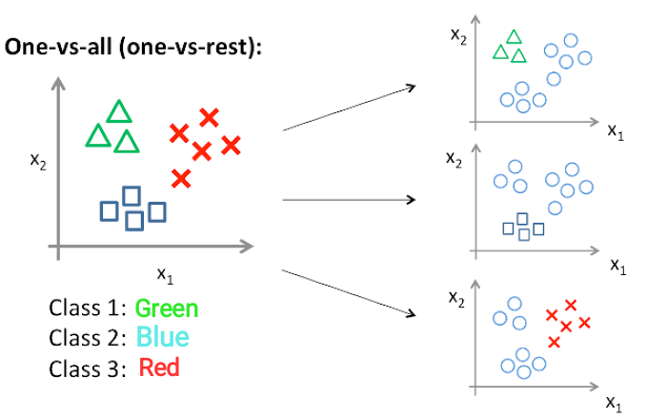
Figure 3. This image depicts the working of One-vs-All classification.

C. LOGISTIC RECURRSION

For the purpose of handwritten digit recognition, Logistic Regression is a useful foundation. It can reach a respectable level of accuracy and offers a strong basis for understanding classification challenges. A "one-vs-all" strategy is employed while using Logistic Regression because there are ten digit classes (0–9). In other words, we train ten different logistic regression models—one for every class of digits. Each model forecasts the likelihood that the image belongs to a particular digit class (0, 1, 2, etc.) using the flattened image vector as input. The weights and biases that optimally divide the data points into several digit classes are taught to the model during training. To optimize these parameters and minimize the cost function, methods such as gradient descent are employed. While logistic regression is primarily used for binary classification, it can be extended to handle multi-class problems using techniques like one-vs-rest or multinomial logistic regression.

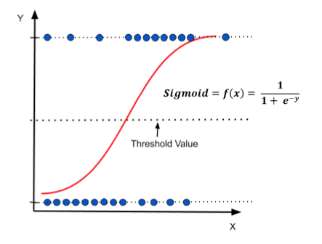

Figure 4. This image is Depiction of Logistic Regression.

D. SUPPORT VECTOR MACHINE

Support Vector Machine (SVM) is a supervised machine learning algorithm. In this, we generally plot data items in n-dimensional space where n is the number of features, a particular coordinate represents the value of a feature, we perform the classification by finding the hyperplane that distinguishes the two classes. It will choose the hyperplane that separates the classes correctly. SVM chooses the extreme vectors that help in creating the hyperplane. These extreme cases are called support vectors, and hence the algorithm is termed as Support Vector Machine. There are mainly two types of SVMs, linear and non-linear SVM. In this paper, we have used Linear SVM for handwritten digit recognition [10].

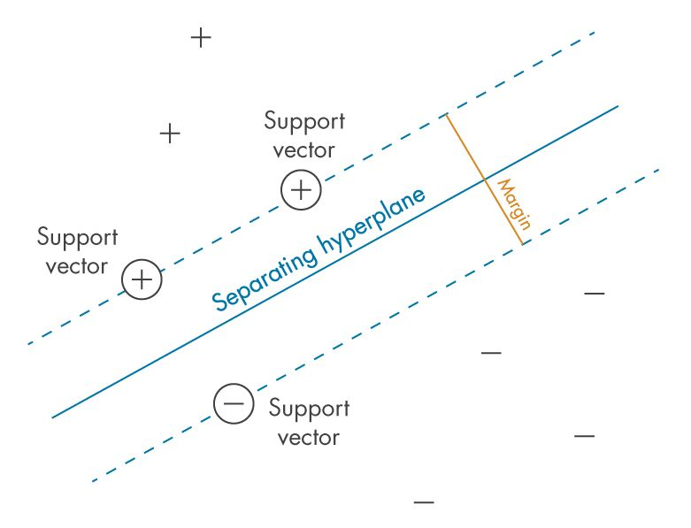
Figure 5. This image describes the working mechanism of SVM Classification with supporting vectors and hyperplanes.

E. RANDOM FOREST CLASSIFIER
Random Forest Classifier is a powerful ensemble learning method for classification tasks. It combines the predictions of multiple decision trees to improve overall accuracy and robustness. Random Forest builds a collection of individual decision trees. Each tree is trained on a random subset of the training data (with replacement, meaning a data point can be chosen multiple times). Additionally, at each node in the tree, a random subset of features is considered for splitting the data. This randomness helps prevent overfitting and introduces diversity into the forest. A fresh data point is fed through each decision tree in the forest when it is brought in for classification. Every tree bases its prediction on the laws it has learned. Ultimately, the random forest's final forecast is the class that each tree predicts will occur the most frequently.
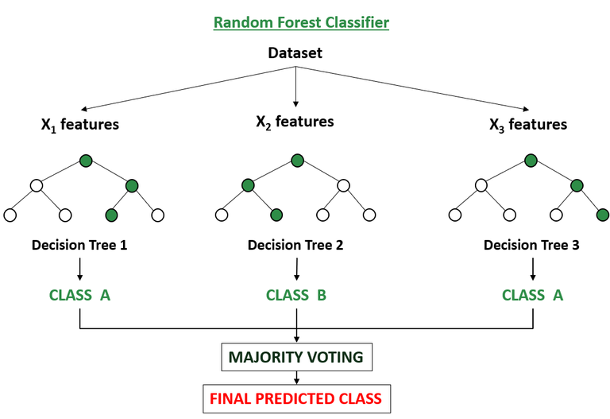
Figure 6. This image provides working of Random Forest Classifier.

F. K-NEAREST NEIGHBORS CLASSIFICATION
Similar data points typically have similar labels or values, which is how KNN operates. It uses the labels of a new data point's nearest neighbours in the training data to predict the class label of the new data point during classification. Regression uses the average value of a data point's nearest neighbours to forecast the value of a new data point. The similarity of data points is measured using a distance metric, such as the Manhattan distance or the Euclidean distance. This establishes the "closeness" between two data points. When formulating a prediction, K is the number of nearest neighbours to take into account. Achieving good performance requires selecting the ideal K value. Most typically, testing is used to determine it. The procedure is comparable to classification, except the average value of a particular characteristic (target variable) from the K nearest neighbours becomes the predicted value for the new data point rather than a class label. For classification and regression applications, KNN is a flexible and well-respected technique. Even with its drawbacks, its interpretability, versatility, and ease of use make it a useful tool in a wide range of machine learning applications.
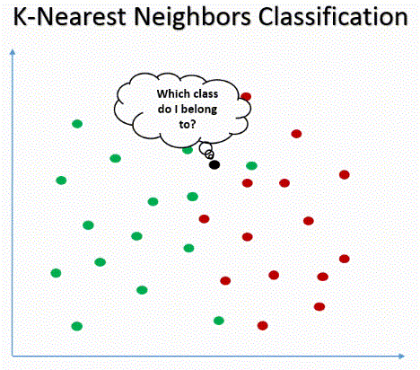
Figure 7. This image shows about KNN classification.

G. CONVOLUTIONAL NEURAL NETWORK
CNN is a popular deep learning technique for classifying and recognizing images. This kind of deep neural network requires very little pre-processing. Instead of entering a single pixel at a time, it enters the image in small pieces, which helps the network identify ambiguous patterns (edges) in the image more quickly. An input layer, an output layer, and several hidden layers, such as convolutional layers, pooling layers (max and average pooling), fully connected layers (FC), and normalizing layers, are the three layers that make up CNN. CNN uses an array of weights as a filter, or kernel, to extract features from the input image. To introduce some non-linearity, CNN uses several activation functions at each layer. The height and breadth of the CNN reduce as we proceed, but the number of channels rises. Ultimately, the outcome is predicted using the created column matrix.
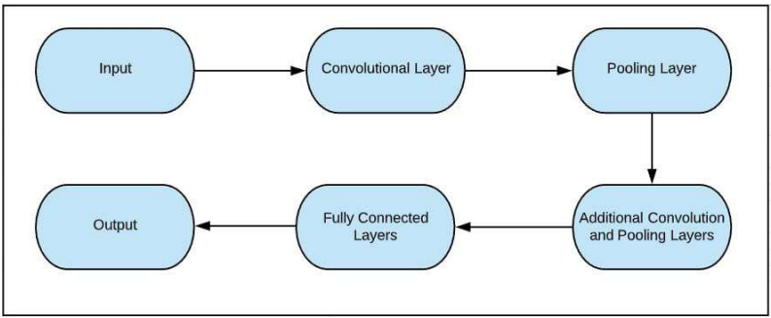
Figure 8. This figure shows the architectural design of CNN layers in the form of a Flow chart.

IMPLEMENTATION
To compare the algorithms based on working accuracy, execution time, complexity, and the number of epochs (in deep learning algorithms) we have used six different ML models:
- Linear Regression
- Logistic Regression
- Support Vector Classifier
- Random Forest Classifier
- K-Nearest Neighbours Classifier
- Convolutional Neural Network
We have discussed in detail about the implementation of each algorithm explicitly below to create a flow of this analysis to create a fluent and accurate comparison.

- PRE-PROCESSING
Pre-processing is an initial step in the machine and deep learning which focuses on improving the input data by reducing unwanted impurities and redundancy. To simplify and break down the input data we reshaped all the images present in the dataset in 2-dimensional images i.e. (28,28,1). Each pixel value of the images lies between 0 to 255 so, we Normalized these pixel values by converting the dataset into ’float32’ and then dividing by 255.0 so that the input features will range between 0.0 to 1.0. Next, we performed one-hot encoding to convert the y values into zeros and ones, making each number categorical, for example, an output value 4 will be converted into an array of zero and one i.e. [0,0,0,0,1,0,0,0,0,0].

- LINEAR REGRESSION
Even while linear regression may not be the most advanced method available, it provides a solid foundation for comprehending the principles of machine learning classification jobs. It's a somewhat easy model to put into practice and offers some interpretability by giving information about the weight distribution of each characteristic. However, in practice, more advanced models are usually employed to achieve higher recognition accuracy. Since we have 10-digit classes (0-9), Linear Regression is used in a "one-vs-all" strategy. This means training 10 separate models, one for each digit class. The weights and biases for the linear equation that best distinguishes the data points belonging to its designated digit class from the remaining digits are learned by each model iteratively. To optimize these parameters and minimize the cost function, methods such as gradient descent are employed.

- LOGISTIC REGRESSION
Because there are ten-digit classes (0–9), we train ten distinct Logistic Regression models (one for each digit class) as before. Logistic regression, as contrast to linear regression, produces an output value that falls between 0 and 1, signifying the likelihood of a picture falling into a particular digit class. As a result, a separate sigmoid function is no longer required. A training dataset including labeled images from each model's designated digit class is used (for example, all photos labelled "5" for the model that predicts digit 5). To minimize the cost function and determine the ideal weights and biases for the logistic regression model, one can employ gradient descent or alternative optimization algorithms.

- SUPPORT VECTOR MACHINE
Both sparse (any scipy.sparse) and dense (numpy.ndarray and convertible to that by numpy.asarray) sample vectors are supported as input by the SVM in scikit-learn. SVC, NuSVC, and LinearSVC are scikit-learn classes that can classify several classes in a given dataset. The MNIST datasets that use a linear kernel built with the aid of LIBLINEAR [17] were classified using LinearSVC in this work. For implementation, several scikit-learn libraries have been used, including NumPy, matplotlib, pandas, Sklearn, and seaborn. The MNIST datasets will first be downloaded, then loaded and the CSV files will be read using pandas. Subsequently, selected data were plotted and converted into a matrix, after which the features were scaled and normalized.

- RANDOM FOREST CLASSIFIER
One Random Forest Classifier is constructed, as opposed to logistic regression using several models. Multiple decision trees are combined in this classifier; each decision tree is trained on a random subset of the data (with replacement), and at each split, a random subset of characteristics is taken into consideration. This unpredictability enhances generalization by reducing overfitting. Using a suitable method such as CART, the Random Forest trains each decision tree separately (Classification and Regression Trees). A new data point's final forecast is determined by adding the predictions (such as majority vote) from each tree in the forest. Based on its acquired decision rules, every tree forecasts a class of digits. The Random Forest Classifier uses the most frequently predicted class label from each tree as its final prediction for the new image. Random Forests often achieve higher accuracy on classification tasks compared to logistic regression due to their ensemble nature and ability to handle complex data better.
- K-NEAREST NEIGHBORS
Explicit model training in the conventional sense is not used with KNN. For use as a guide throughout the prediction stage, the complete training dataset is stored. The preprocessing of the new handwritten digit picture is identical to that of the training data. Using a distance metric such as the Manhattan distance or the Euclidean distance, KNN determines the distance between each new image vector (features) and every image vector in the training data. KNN finds the K data points from the training set that are closest to the new image in terms of the distance measure, based on the selected K value (number of neighbours). The class label (digit) that occurs the most frequently among the K nearest neighbors is predicted by KNN.

- CONVULATIONAL NEURAL NETWORK
The implementation of handwritten digit recognition by Convolutional Neural Network [15] is done using Keras. It is an open-source neural network library that is used to design and implement deep learning models. From Keras, we have used a Sequential class which allowed us to create model layer-by-layer. The dimension of the input image is set to 28(Height), 28(Width), 1(Number of channels). Next, we created the model whose first layer is a Conv layer [20]. This layer uses a matrix to convolve around the input data across its height and width and extract features from it. This matrix is called a Filter or Kernel. The values in the filter matrix are weights. We have used 32 filters each of the dimensions (3,3) with a stride of 1. Stride determines the number of pixels shifts. Convolution of filter over the input data gives us activation maps whose dimension is given by the formula: ((N + 2P - F)/S) + 1 where N= dimension of input image, P= padding, F= filter dimension and S=stride. In this layer, Depth (number of channels) of the output image is equal to the number of filters used. To increase the non-linearity, we have used an activation function that is Relu [21]. Next, another convolutional layer is used in which we have applied 64 filters of the same dimensions (3,3) with a stride of 1 and the Relu function. Next, to these layers, the pooling layer [22] is used which reduces the dimensionality of the image and computation in the network. We have employed MAX-pooling which keeps only the maximum value from a pool. The depth of the network remains unchanged in this layer. We have kept the pool-size (2,2) with a stride of 2, so every 4 pixels will become a single pixel. To avoid overfitting in the model, Dropout layer [23] is used which drops some neurons which are chosen randomly so that the model can be simplified. We have set the probability of a node getting dropped out to 0.25 or 25%. Following it, Flatten Layer [23] is used which involves flattening i.e. generating a column matrix (vector) from the 2-dimensional matrix. This column vector will be fed into the fully connected layer [24]. This layer consists of 128 neurons with a dropout probability of 0.5 or 50%. After applying the Relu activation function, the output is fed into the last layer of the model that is the output layer. This layer has 10 neurons that represent classes (numbers from 0 to 9) and the SoftMax function [25] is employed to perform the classification. This function returns probability distribution over all the 10 classes. The class with the maximum probability is the output.
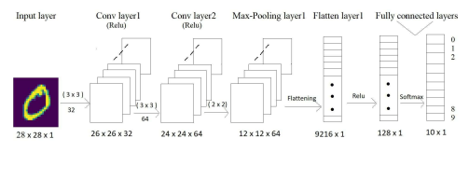
Figure 9. Detailed architecture of Convolutional Neural Network with apt specifications of each layer

RESULT
After implementing all the six algorithms that are Linear Regression, Logistic Regression, SVM, Random Forest, KNN and CNN we have compared their accuracies and execution time with the help of experimental graphs for perspicuous understanding. We have taken into account the Training and Testing Accuracy of all the models stated above. After executing all the models, we found that SVM has the highest accuracy on training data while on testing dataset CNN accomplishes the utmost accuracy. Additionally, we have compared the execution time to gain more insight into the working of the algorithms. Generally, the running time of an algorithm depends on the number of operations it has performed. So, we have trained our deep learning model up to 30 epochs and SVM models according to norms to get the apt outcome. SVM took the minimum time for execution while CNN accounts for the maximum running time.

TABLE I
COMPARISON ACCURACY OF DIFFERENT MODELS
MODEL | ACUURACY
Linear Regression | 12.08%
Logistic Regression | 91.05%
SVM | 96.03%
Random Forest | 96.38%
KNN | 96.55%
CNN | 99.31%
This table represents the overall performance for each model. The table contains 2 columns, the 1st column represents model and the 2nd column represents model accuracy.

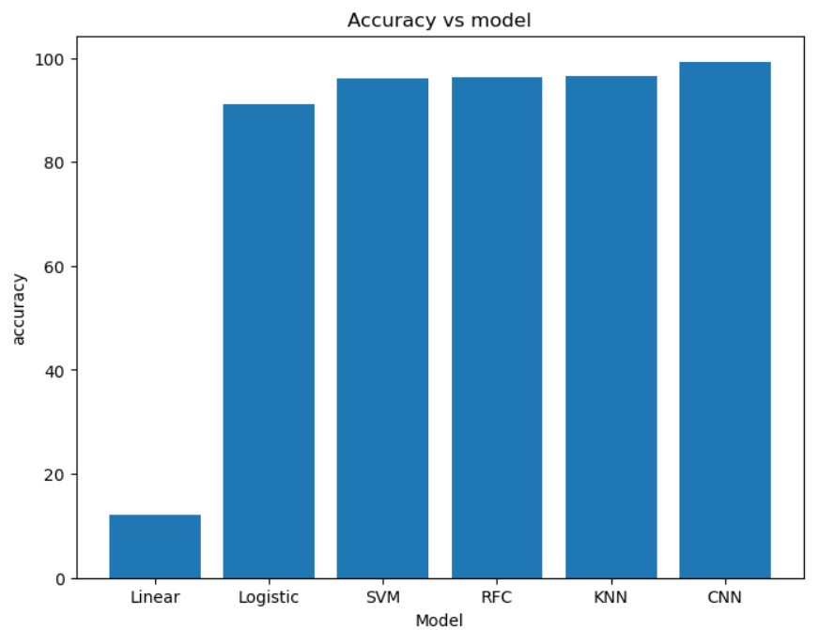
Figure 10. A Bar graph depicting accuracy comparison of each model.

Furthermore, we visualized the performance measure of deep learning models and how they ameliorated their accuracy and reduced the error rate concerning the number of epochs. The significance of sketching the graph is to know where we should apply early stop so that we can avoid the problem of overfitting as after some epochs, change in accuracy becomes constant.

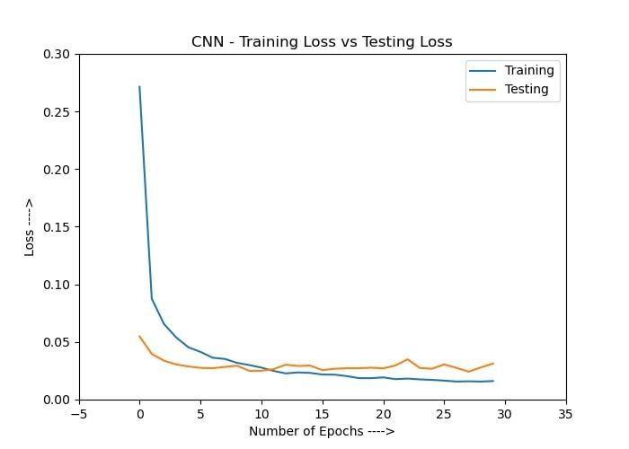
Figure 11. Graph illustrating the transition of training loss of CNN with increasing number of epochs (Loss rate v/s Number of epochs)

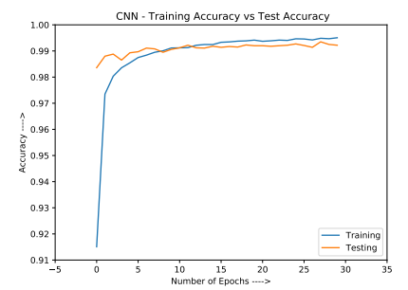
Figure 12. Graph illustrating the transition of training accuracy of CNN with increasing number of epochs (Accuracy v/s Number of epochs).

CONCLUSION
In this research, we have implemented six models for handwritten digit recognition using MNIST datasets, based on deep and machine learning algorithms. We compared them based on their characteristics to appraise the most accurate model among them. Support vector machines are one of the basic classifiers that’s why it’s faster than most algorithms and in this case, gives the maximum training accuracy rate but due to its simplicity, it’s not possible to classify complex and ambiguous images as accurately as achieved with CNN algorithm. We have found that CNN gave the most accurate results for handwritten digit recognition. So, this makes us conclude that CNN is best suitable for any type of prediction problem including image data as an input. Because linear regression presupposes a linear connection between features and labels, which may not hold true for complicated data like handwritten digits, it is not appropriate for classification tasks like digit identification, despite being straightforward and quick to implement. Because it can handle non-linear connections between features and labels and produce probabilities, logistic regression outperforms linear regression in classification problems. It might, however, have trouble processing intricate datasets with extremely non-linear relationships, such as handwritten digits.
Suitable for handwritten digit recognition, SVMs are strong classifiers that perform well in both linear and non-linear classification tasks. By maximizing the margin between classes and minimizing overfitting, they identify the ideal hyperplane that will perform well when applied to previously unseen data. Decision tree ensembles known as random forests are resistant to overfitting and have good handling power for high-dimensional data. By combining the predictions of several decision trees, they perform well for handwritten digit recognition, improving both accuracy and generalization. KNN is a straightforward algorithm that works well for classification jobs. It functions by identifying the majority class among a given data point's k-nearest neighbours. Although KNN can be effective in handwritten digit recognition, there are potential drawbacks, including high computational costs and sensitivity to k selection. Next, by comparing execution time of the algorithms we have concluded that increasing the number of epochs without changing the configuration of the algorithm is useless because of the limitation of a certain model and we have noticed that after a certain number of epochs the model starts overfitting the dataset and give us the biased prediction.

FUTURE SCOPE
The future development of the applications based on algorithms of deep and machine learning is practically boundless. In the future, we can work on a denser or hybrid algorithm than the current set of algorithms with more manifold data to achieve the solutions to many problems. In future, the application of these algorithms lies from the public to high-level authorities, as from the differentiation of the algorithms above and with future development we can attain high-level functioning applications which can be used in the classified or government agencies as well as for the common people, we can use these algorithms in hospitals application for detailed medical diagnosis, treatment and monitoring the patients, we can use it in surveillances system to keep tracks of the suspicious activity under the system, in fingerprint and retinal scanners, database filtering applications, Equipment checking for national forces and many more problems of both major and minor category. The advancement in this field can help us create an environment of safety, awareness and comfort by using these algorithms in day-to-day application and high-level application (i.e. corporate level or Government level). Application-based on artificial intelligence and deep learning is the future of the technological world because of their absolute accuracy and advantages over many major problems.

